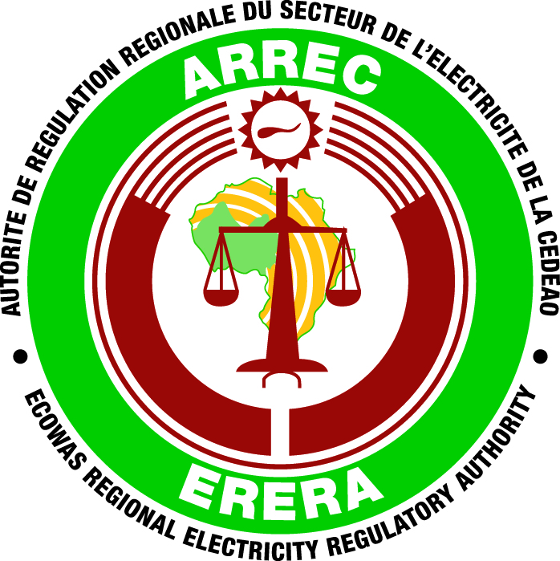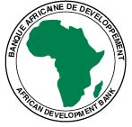

**ECOWAS REGIONAL ELECTRICITY REGULATORY AUTHORITY (ERERA)**

**SPECIFIC PROCUREMENT NOTICE**

**REQUEST FOR EXPRESSIONS OF INTEREST**

**(CONSULTING SERVICES)**

**COUNTRY : Ghana**

**NAME OF PROJECT :** **Regional harmonization of regulatory frameworks and tools for**

**improved electricity regulation in ECOWAS**

**PROJECT ID : P-Z1-FA0-189**

**GRANT No. : 2100155041676**

**CONTRACT NAME :**  Individual Consultant as Project coordinator

**IFB NO. :** ERA/PROG/RHRFTIERE/AfDB/SER/ICS2023/11

**CONTRACT NAME :** Individual Consultant as Procurement specialist

**IFB NO. :** ERA/PROG/RHRFTIERE/AfDB/SER/ICS2023/12

The ECOWAS Regional Electricity Regulatory Authority (ERERA) has received funding from the *African Development Fund* in the form of a *“Grant”* toward the cost of undertaking studies and developing appropriate tools and instruments to facilitate the harmonization of regional regulatory frameworks in the ECOWAS region.

ERERA intends to apply a portion of the agreed amount for this grant to eligible long-term staff costs for program management of the Harmonization of Regulatory Frameworks and Tools for Improved Electricity Regulation in ECOWAS.

The principal objective of this project is to facilitate the efficient utilization of regional energy infrastructure to further enhance regional electricity trade. Through these activities and the resulting tools, ERERA will assist national regulatory bodies to acquire adequate knowledge that would enable them to carry out the necessary regulatory work in developing the regional market at the national level.

The program will focus on the following components: (i) Development of Regulatory and Utility Key Performance Indicators (KPIs) for ECOWAS, (ii) Harmonised Comparison of Electricity Tariffs (HCET) in ECOWAS and Cost Reflectivity Assessment, (iii) Development of a Climate-informed Energy Information and Database Management System (EIDBMS), (iv) Assessment of Investment bottlenecks and risks in ECOWAS member countries, and (v) Program Management which will be co-financed with ERERA.

ECOWAS Regional Electricity Regulatory Authority (ERERA) now invites eligible candidates to apply for the following Project Management Unit positions:

|  |  |  |
| --- | --- | --- |
| **S/N** | **Description of assignment** | **IFB NO.** |
| 1 | Consultancy Services for the coordination of the project | ERA/PROG/RHRFTIERE/AfDB/SER/ICS2023/11 |
| 2 | Consultancy Services for procurement | ERA/PROG/RHRFTIERE/AfDB/SER/ICS/2023/12 |

\****Eligible Individual Consultants (ICS) are to express interest in any of the above assignments.***

Details of all the Terms of Reference are available for interested individual consultants at these websites: [www.ecowas.int](http://www.ecowas.int); [www.afdb.org](http://www.afdb.org) and [www.erera.arrec.org](http://www.erera.arrec.org).

Interested individual consultants must provide information indicating that they are qualified to perform the required services (description of similar assignments, experience in similar conditions, availability, etc.).

Eligibility criteria, the establishment of the short-list and the selection procedure shall be in accordance with the African Development Bank’s “Rules and Procedures for the Use of Consultants” October 2015, which is available on the Bank’s website at [www.afdb.org](http://www.afdb.org).

Interested individual consultants may obtain further information at the address below during office hours from 9.00 am to 5.00 pm Monday through Friday (excluding public holidays) at the address below from 12 June 2023 to 28 July 2023.

Expressions of interest must be delivered to the address below by **31 July 2023** at 17:00 hours and marked: “**Regional harmonization of regulatory frameworks and tools for improved electricity regulation in ECOWAS”**

1. Consultancy Services as a project coordinator - ERA/PROG/RHRFTIERE/AfDB/SER/ICS/2023/11
2. Consultancy Services as a procurement specialist - ERA/PROG/RHRFTIERE/AfDB/SER/ICS/2023/12

Attn: ERERA

PMB 76 Ministries Post Office Accra, Ghana

Physical Location

Energy Commission Building, Ghana Airways Avenue

Behind Alliance Française, Airport Residential Area,

Accra, Ghana

Tel: +233 (0) 302 817 047-049

**Email:** [info@erera.arrec.org](mailto:info@erera.arrec.org)